Ethan Kent

Linux Administrator Fall 2022

Ubuntu Server: Installed the default Ubuntu Sever option.

To begin making a virtual machine server you’ll need the right software. In this case I will be using VMware Workstation 16 Player. You can visit the VMware site to find and install this product. The installation is simple and will just have you hit the next button until it installs. Once you have it installed it should look like this. You will just have the home window though. 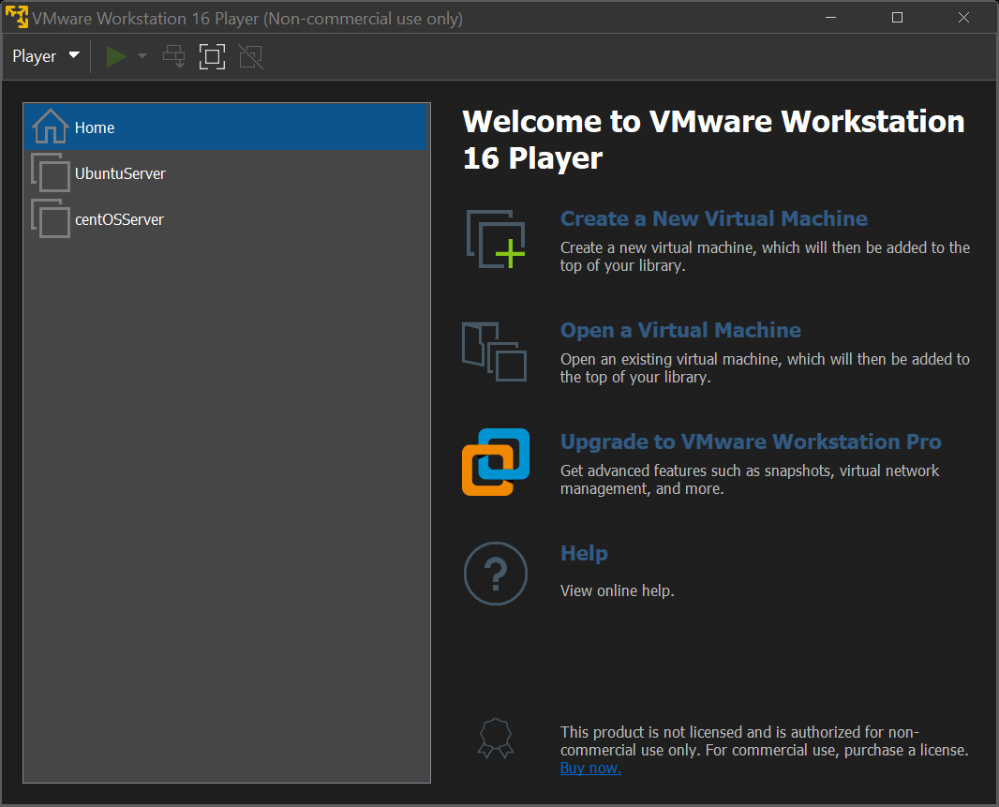

To begin setting up a virtual machine we will first need the system that we want to run. In these instances, we are going to be using Ubuntu Server and CentOS. To get these I did a quick search online for the respective names and then ISO. They should have sites from the developers where they let you download the file. Once downloaded I suggest making a folder to store them. We will use it later. Once you have both ISO files now we can go to the VMware station we installed. Now click on the “Create a New Virtual Machine” now you should be greeted with this.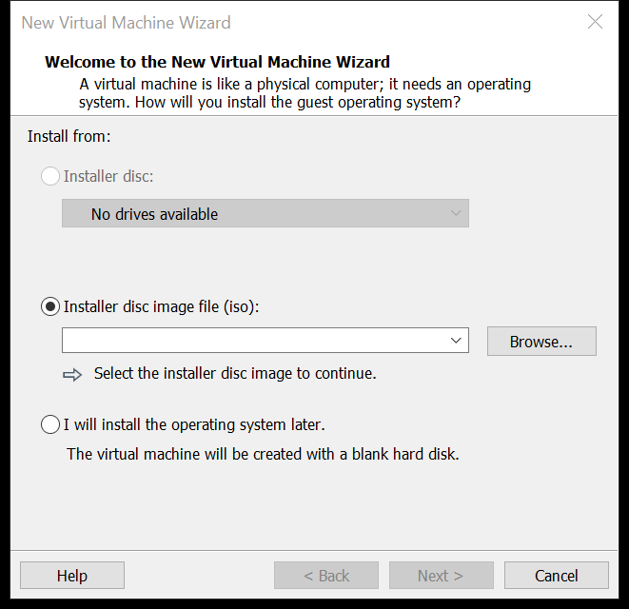

We will be using the second option; this is why we downloaded the ISO files. Find the folder you created to store the ISO files and select ether of the two (I will be starting with the Ubuntu server option first). Now name the server and continue. Then you will be asked how much space you would like to allocate to the server. I leave it as default as 20 GBs should be more then enough. I also use the split disk option. This is just incase if we needed to move our virtual machine, makes it easier than one whole disk.

After that it will show you the options you selected. Look through them to see if it’s to your liking and if so click the create button. We now have virtual machine! Though we still need to set it up.

Launch the virtual machine by clicking on it and clicking  or you can double click. Once open you will click the first option, this is to select our installation of the Ubuntu server. The rest is very straightforward, it will be setting things up on its own for the most part. We just need to set up our username and password to get in along with some options for the server. Some options though the installation like “OpenSSH” I did not install, I also did not install any of the additional software that is presented at the end. We can always install what we need once we figure it out later on, if you already know then definitely select what you need from that page. Now we let the server finish setting things up and we can log in! below is what you should have after it completes the installation.

We will be using the SCP fileshare system. This is installed by default in many Linux systems though. To check if it is installed in your use this command “which scp” if it is installed it will show you a path. If it is not installed it will give you a message along the lines of “No scp version found”

If so visit this site to learn how to install it for your server <https://linuxhint.com/linux_scp_command/>

For more information about SCP go to the bottom of the document.

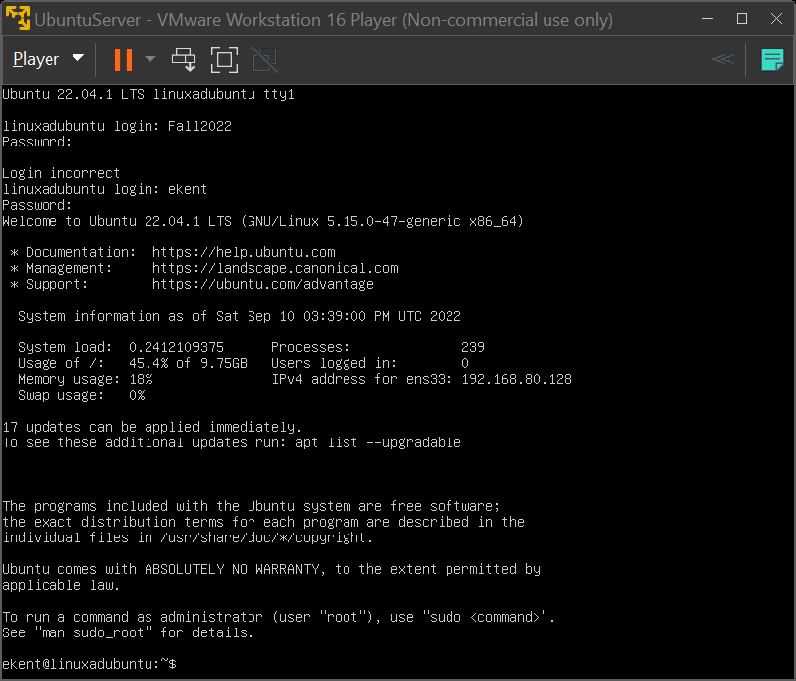

My Ubuntu server after installation and logging in ^

centOS installation.

To install our second server, you’re going to be repeating the same steps in our Ubuntu server. Though centOS will ask for you name and to create a user in the VMware set up. Just do that and the steps before and then you can begin setting up the server.

With the centOS install it will bring us to page of options that we need to set up. For starters it will have us select a disk to use. We will only have the one 20GB we set up beforehand. Below are the options I selected. (Make sure you select SERVER and not the server with GUI)

* Enabled root SSH with password
* Made my user an administrator
* Selected the Server option instead of default “Server with GUI” did not select any additional software
* 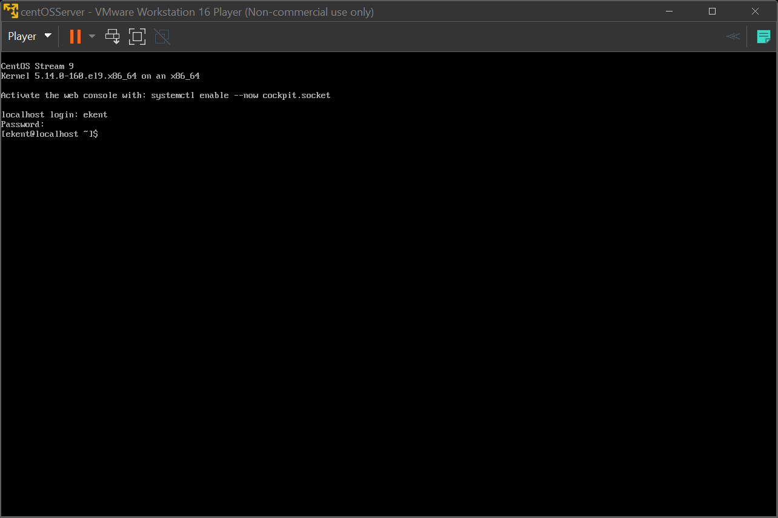
* The centOS server after installation above

I will be using SCP for the fileshare for the centOS server and Ubuntu server. SCP is used to send files securely and able to send them remotely, as long as the other system has SSH set up. This is needed as SSH is the part that does the securing and protection of the files sent with SCP.

Here is an example of a file being sent from the Ubuntu server to the Centos server. We can see the CentOS server has nothing in its home directory.



Over on the Ubuntu server I have a file to transfer. To transfer it I entered the name of the file, where I wanted it to go. In this case I sent it to the CentOS server, then I had it just go to the home directory since there isn’t any other directories currently. After I entered my password, we can see it gave us a 100%, this indicating that the file was sent, so lets check the CentOS server.

checking once again we can see that the file safely made it! So a way to break down the scp command would be, scp (command) GrepLab (the file) IP address (CentOS server) and /GrepLab the copy’s name as it will appear on the other side. we sent to CentOS.